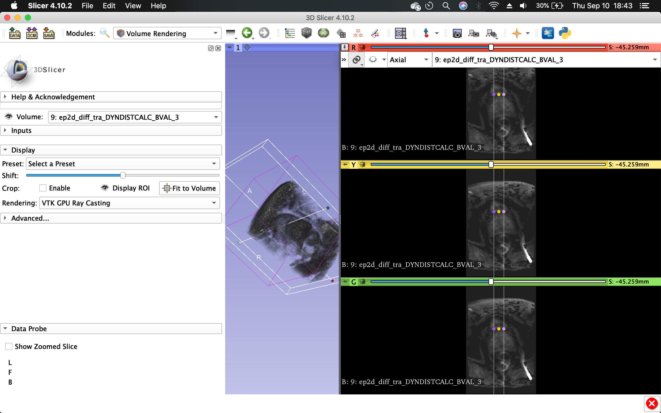

DICOM

KTrans